2. Install Oracle Database

Use this link to initiate the download:

<http://www.oracle.com/technetwork/database/database-technologies/express-edition/downloads/index.html>

And select [Oracle Database 21c Express Edition for Windows x64](http://www.oracle.com/technetwork/database/database-technologies/express-edition/downloads/index.html)

Tap on the setup file to begin:

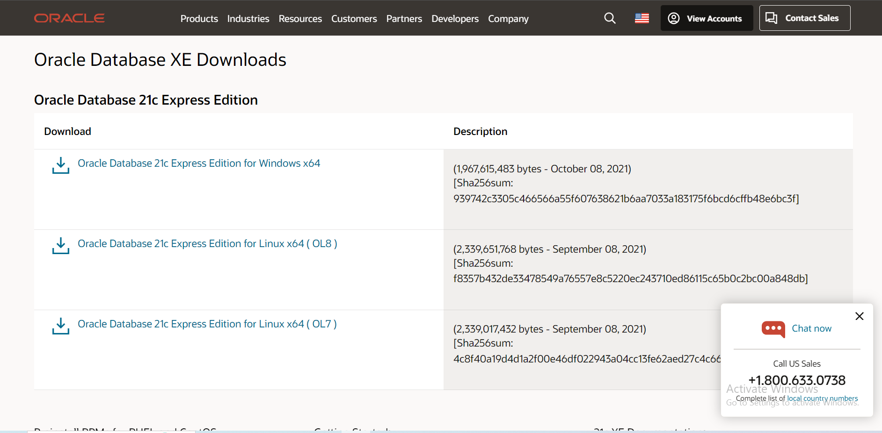

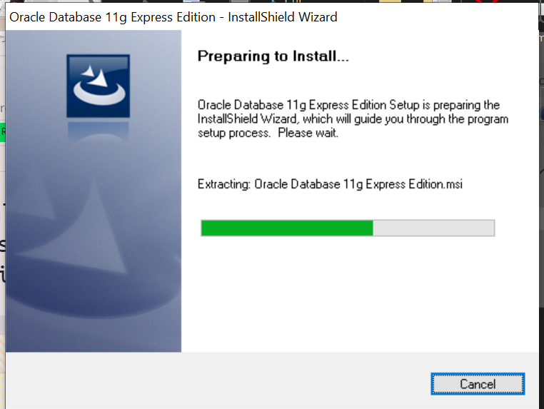

Click Next

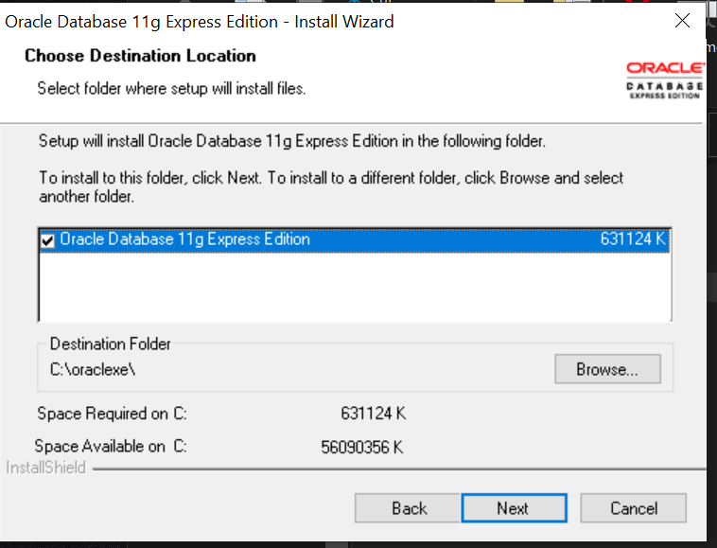

Select the location for installation, then press Next to continue.

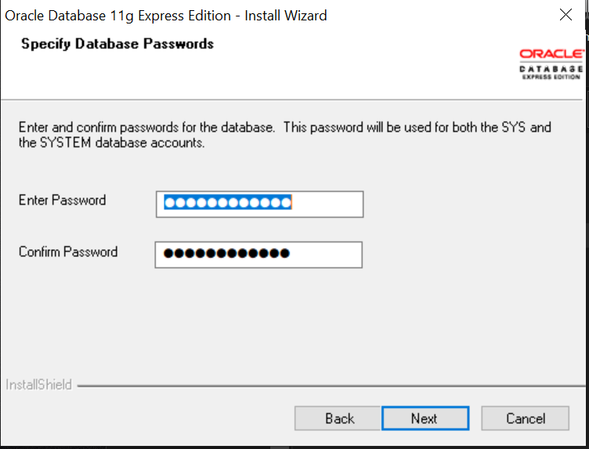

Set your password to “confirm” and go to the next step.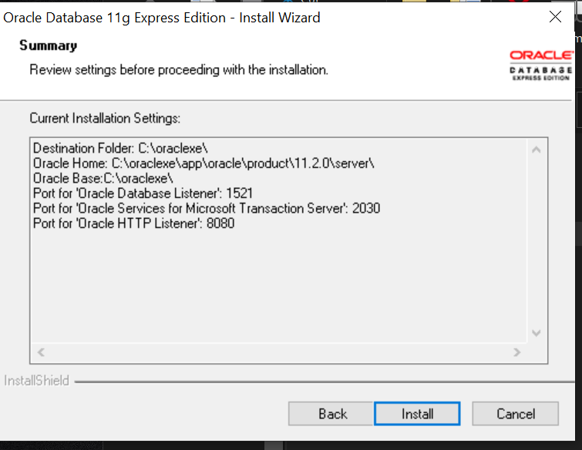

"Click on the 'Install' button. After Oracle finishes installing, this screen will show up."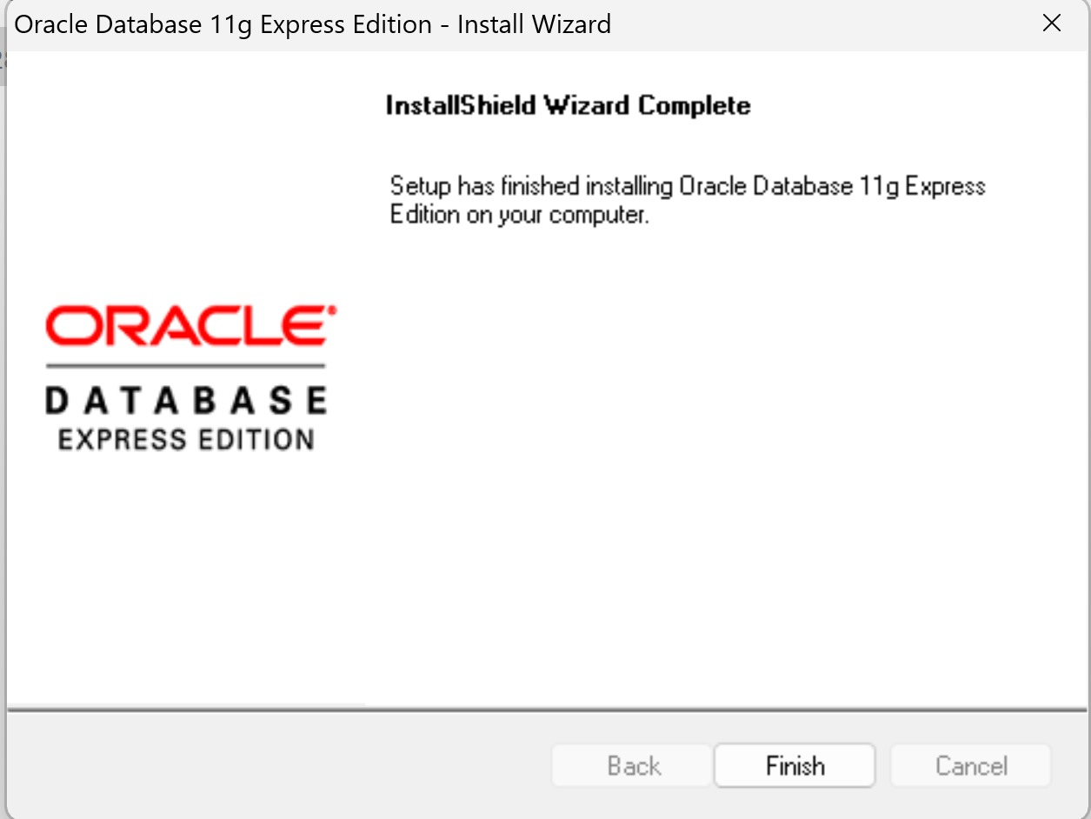

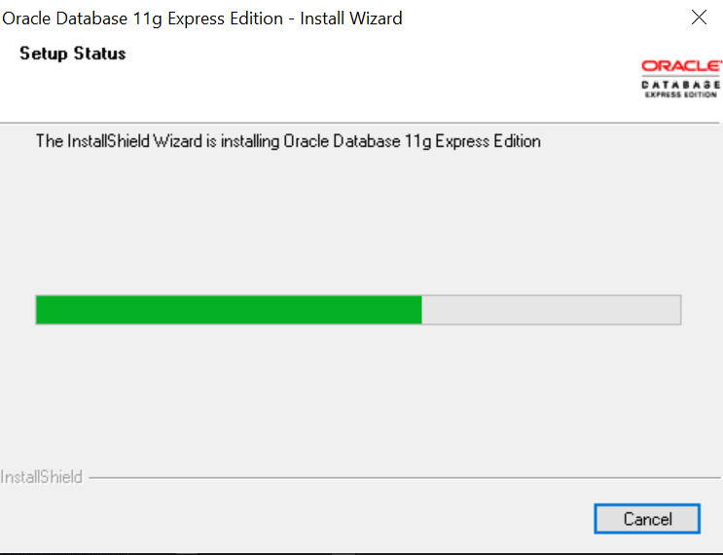

Wait for installation process to complete

After the download finishes, run the command prompt and open the APEX directory on your computer

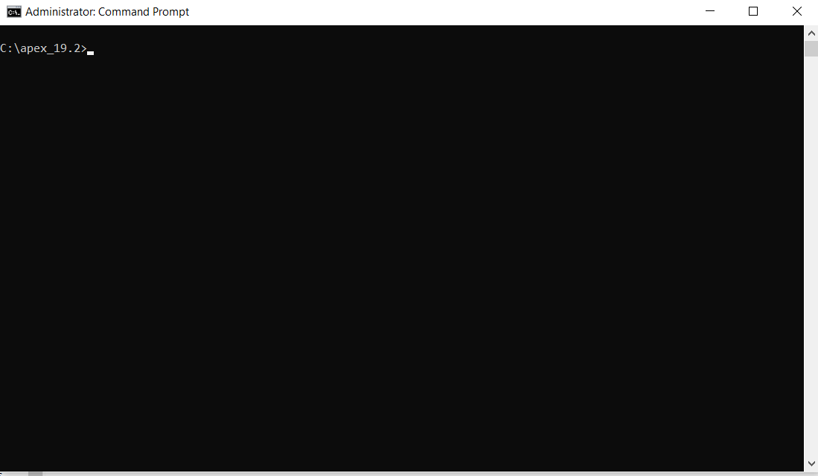

Execute these commands to install Oracle locally and attach the CSS files.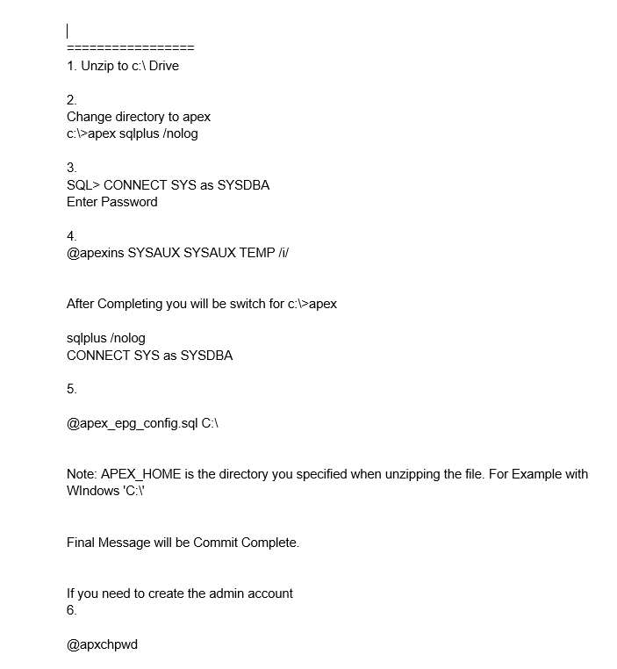

Open which browser you like and go to the following link

<http://localhost:8080/apex/f?p=4550:10:5221011416081>:::::

After accessing the link, the signup page appears, where you need to input the login information created via the command prompt.

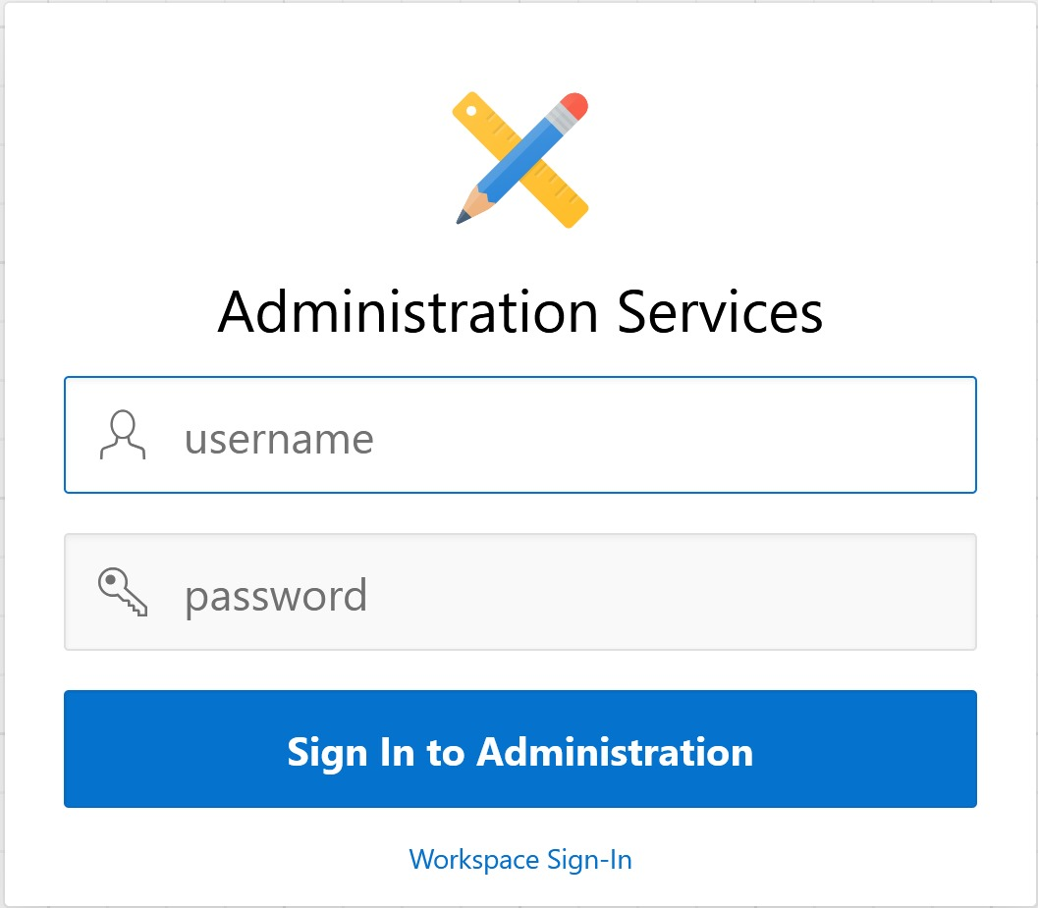

Enter username: Team6

Enter password: teammembers

After accessing the link, the signup page appears, where you need to input the login information created via the command prompt

.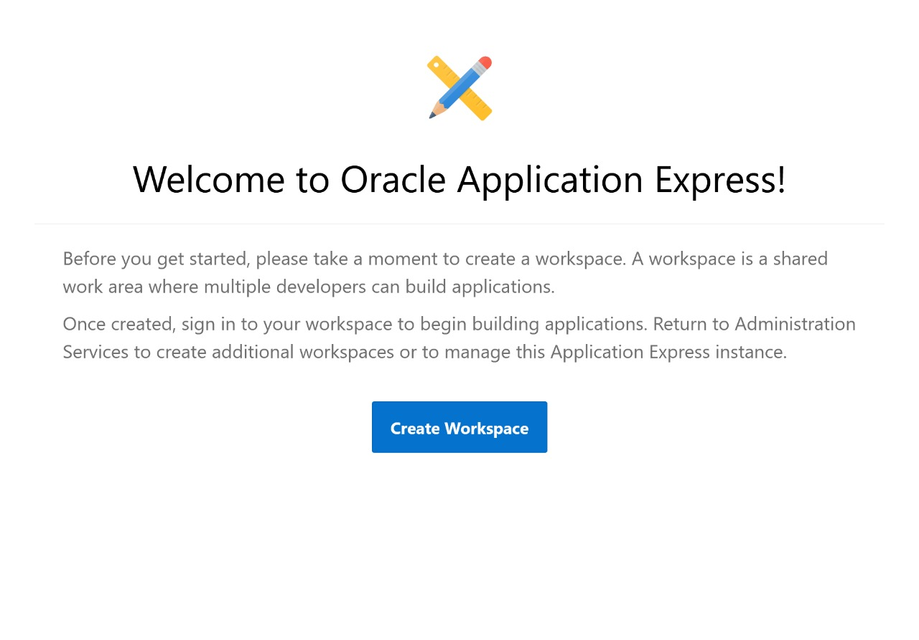

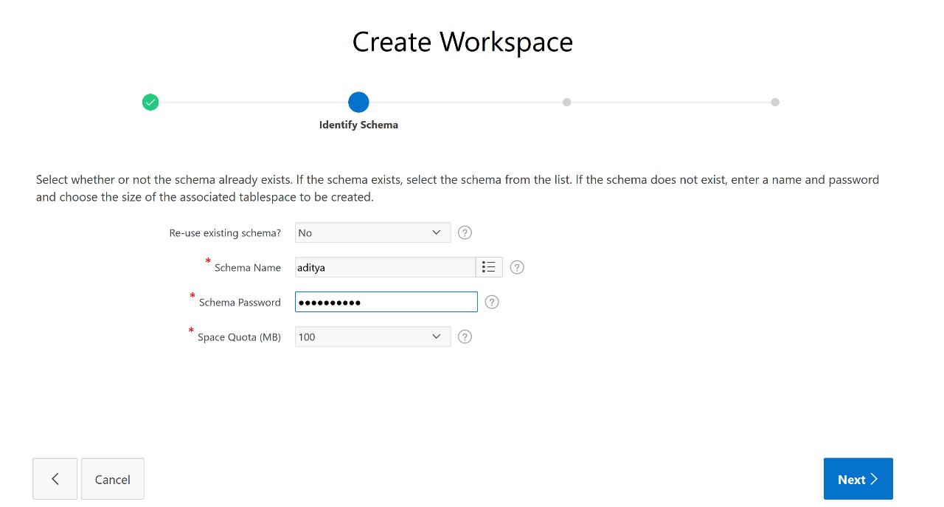

Create your schema and enter the password. Enter the rememberable password as we will be needing it in future.

Schema Name: Team6

Schema Password: teammembers

After the completion of the workspace creation you need to login into workspace to code so go to the following link

<http://localhost:8080/apex/f?p=4550:1:2364460883978>:::::

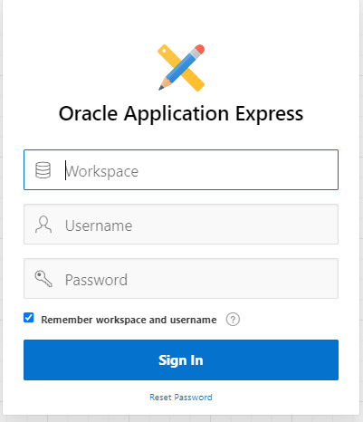

Click here to login.

Workspace name: Team6 Use your password: teammembers

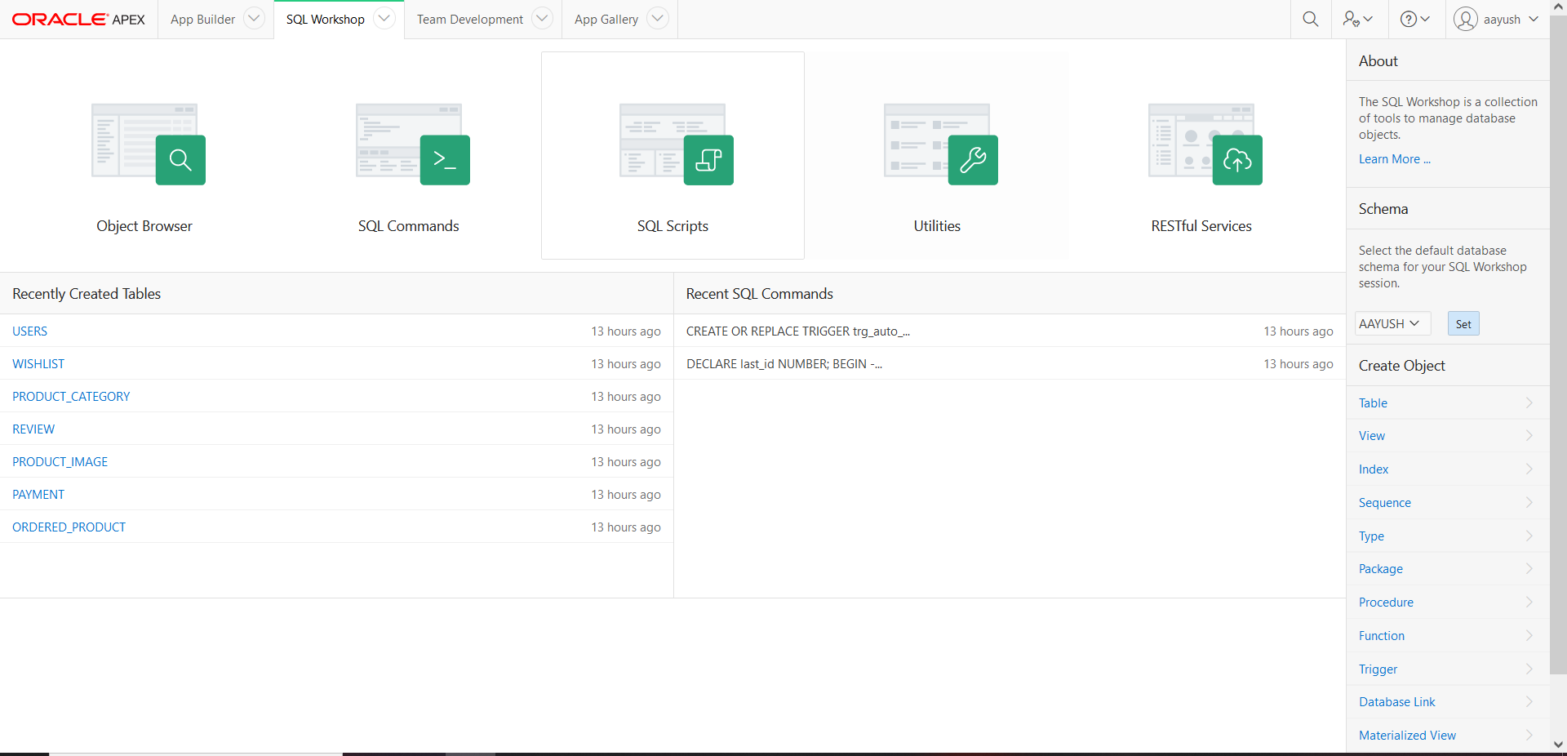

This is the Oracle APEX home page.

Choose 'Upload' to upload your script file.

Click on 'Choose File' and select the localmarket.sql file to upload.

Further Configuration

In the Apache section, click on 'Config' and choose 'PHP (php.ini)' from the dropdown menu.

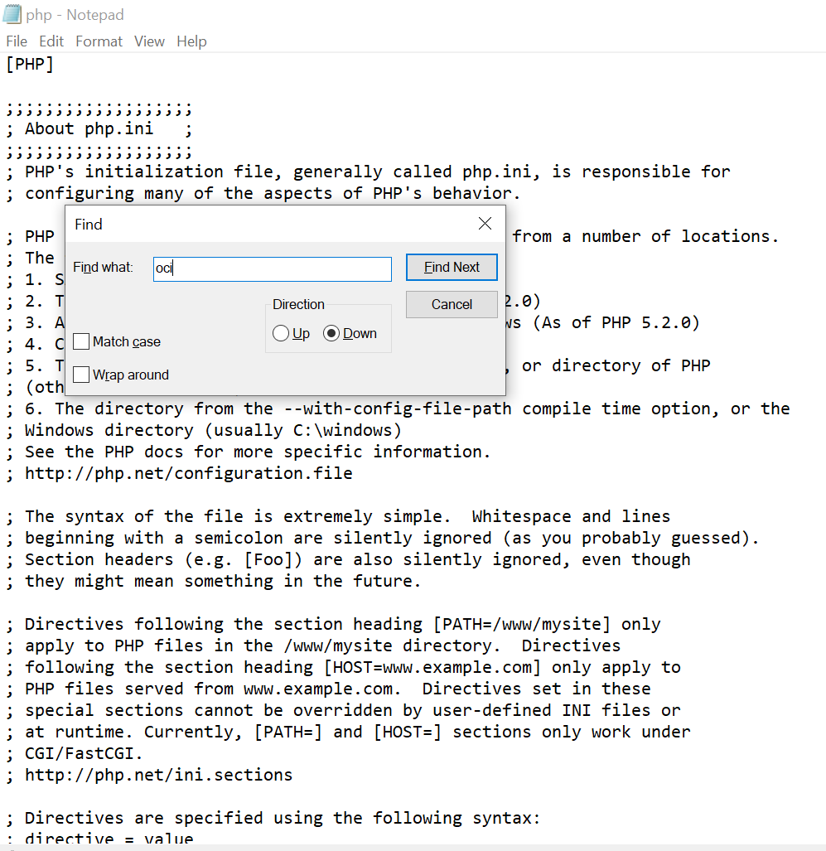

Hold Ctrl + F button and find for “oci” keyword.

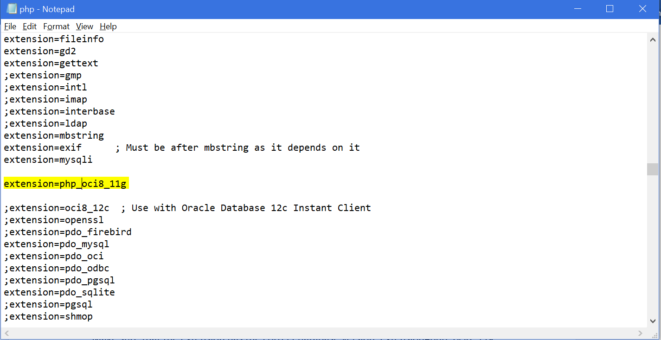

Ensure the extension is set to the appropriate database version: extension=php_oci8_11g

Save your changes and close the file.

